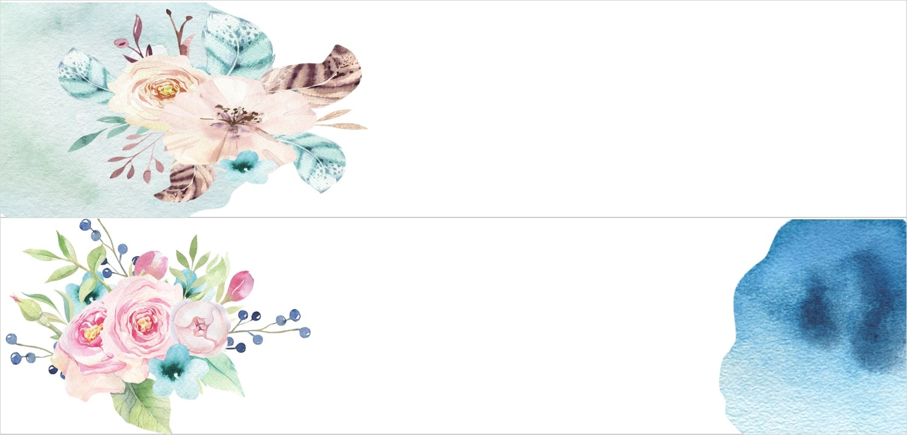
Gift Certificate

Gift Certificate

Gift Certificate

Gift Certificate

Gift Certificate

Gift Certificate

